**WEEK 7 HANDSON -REACT**

**HandsOn 10 :**

**In this hands-on lab, you will learn how to:**

* **Use JSX syntax in React applications**
* **Use inline CSS in JSX**

**CODES AND OUTPUT :**

**Create a React Application named “officespacerentalapp” which uses React JSX to create elements, attributes and renders DOM to display the page.**

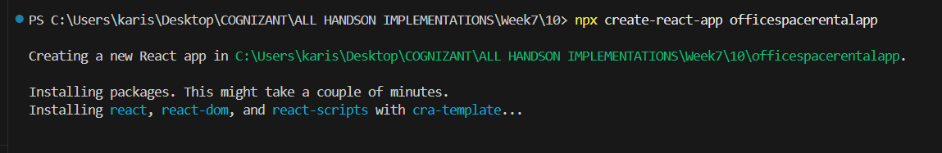

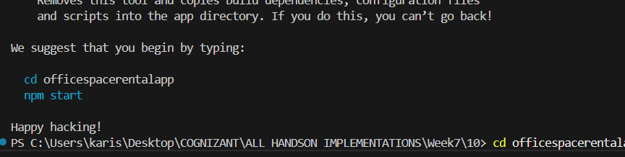

**Create an element to display the heading of the page.**

  const heading = <h1>🏢 Office Space Rental App</h1>;

**Attribute to display the image of the office space**

import spaceRentalImage from "./assets/space_rental.jpg";

<img

src={spaceRentalImage}

alt="Office Space"

style={{

width: "500px",

height: "250px",

borderRadius: "10px",

margin: "20px 0"

}}

/>

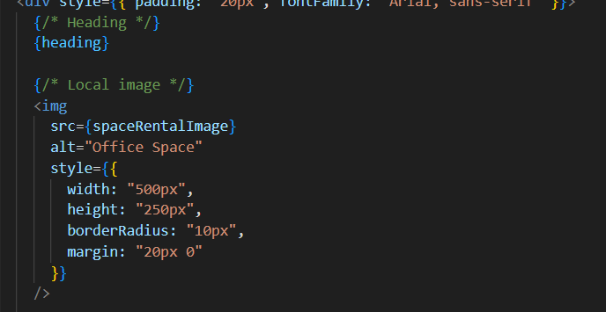

**Create an object of office to display the details like Name, Rent and Address.**

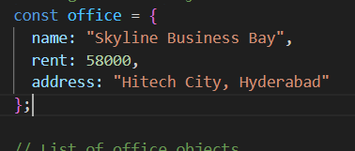

**Create a list of Object and loop through the office space item to display more data.**

const offices = [

    { name: "T-Hub", rent: 70000, address: "Gachibowli, Hyderabad" },

    { name: "WeWork", rent: 65000, address: "Madhapur, Hyderabad" },

    { name: "Cowork Studio", rent: 45000, address: "Ameerpet, Hyderabad" },

    { name: "SmartDesk", rent: 60000, address: "Jubilee Hills, Hyderabad" }

  ];

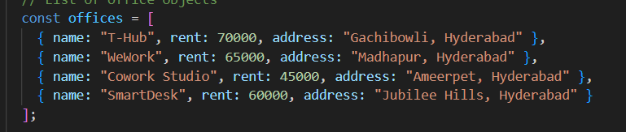

**To apply Css, Display the color of the Rent in Red if it’s below 60000 and in Green if it’s above 60000.**

**const rentStyle = (rent) => ({**

**color: rent > 60000 ? "green" : "red",**

**fontWeight: "bold"**

**});**

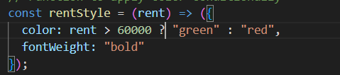

**FULL CODE :**

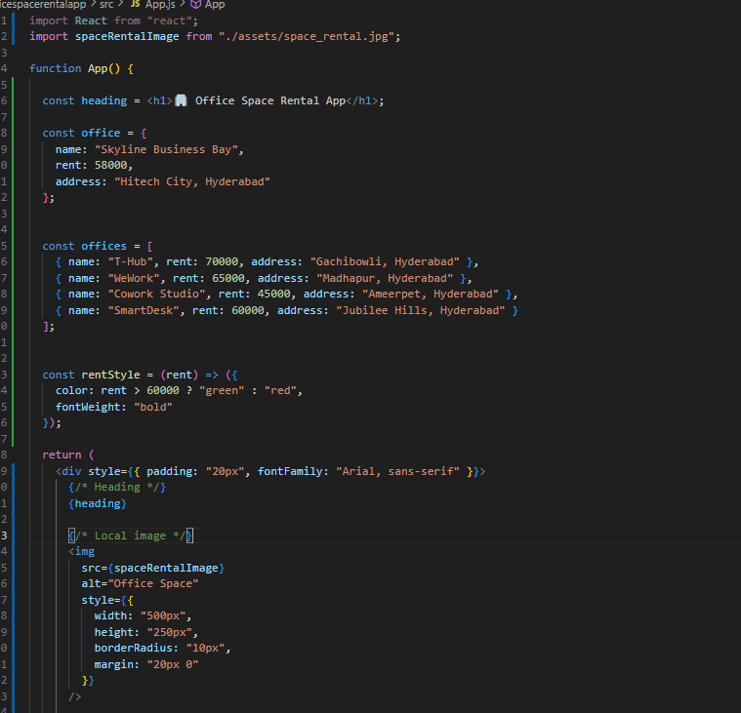

Output :

